Activity sheets

Activity sheet: Communities

A
Gidhawal community elects an elder to make decisions on behalf of their community members. Community members can request a time to go and speak to their elder in order to address issues in their community.

B
Twinomish community elects members to be part of their Senate, the governing body, who makes decisions on behalf of their community members. The Senate can make laws, but it has to ensure that laws are not in contravention with any of the rights and freedoms of its community members.

C
Samis the son of Pinus and Temiramis, makes all of the decisions in the Durrian community. Although community members can own property, ultimately Samis can create a law which takes it away from them. Community members are not allowed to speak against Samis or his decisions.

D
In Monte Rose, all community members need to vote on important issues, such as changes or creation of new laws. The community is run by executive committees who cannot make laws but are there to run community shared services and resources.

Activity sheet: Values and rights

Jamali is a 13 year old girl who was married to a 34 year old male.
Should this be permitted? Would this happen in Australia? Why?

A Russian punk band staged an anti-government protest in the Cathedral Of Christ the Saviour, seizing part of the cathedral and chanting 'Mother Mary, drive Putin away.' The band was arrested and sent to a trial.
If you were part of the jury, what would you do?
Would you convict them or not? Why?

Should asylum seekers, people who seek refuge in Australia due to persecution in their own country be labelled ‘illegal’?

In Australia, should all states have ‘the right to die’ legislation? This would mean that a person is able to make a decision about when and how they will die.
If yes or no, why?

Should we have a law that bans international students from purchasing and having pets in Australia? When they leave the country these pets are either released or given to a shelter.

Should your parents be able to search your room when you are away?

Should young people be paid the same amount as adults doing the same job?

If you knew a product you really want is made in sweatshops in Bangladesh, meaning that it is cheaper for you to buy, would you buy it? Why or why not?

In a local community, McDonalds wishes to build a restaurant. The majority of the locals oppose this idea, however council approves the plans. The local community protests and blocks the builders entering the site.
What would you do? Join the protest or not, and if so why?

Activity sheets

Activity sheet: Is it an issue?

GROUP: WORDS
PROBLEM MATTER SITUATION EVENT CONCERN SOLUTION
Your group has two tasks:
- Decide which of the above words explain best what the word ‘ISSUE’ means?
- What example can you use to explain to someone the meaning of the word issue and one of the words above?
Example:
- EVENT
- A tanker’s oil spill in the ocean is an example of an event, that is related to the issue of environmental pollution.

GROUP: SCENARIOS
Read all of the scenarios and as a group decide if they represent a community issue, or personal issue?
The local arts centre is closing as the building requires urgent repairs. The spaces inside the building are rented to local community groups; however this income does not cover the cost of running the building. Local council has decided to sell the property. | At a newly built estate, residents are parking on both sides of the road. As the road is very narrow there can be only one car driving down the street.
Margaret is a 16-year-old who started smoking. She tried quitting several times but with no success. She works on weekends in order to afford cigarettes. | After finishing year 10 Mohamed was employed as an apprentice with a local tiler. It has taken him a few months of searching, so he was extremely happy when he finally received a positive response. Mohamed is fairly shy but hardworking, and he rarely speaks out for himself. Since starting as an apprentice he has been given increasingly harder tasks as well as being asked to work longer hours.

GROUP: STATEMENTS
Your group has two tasks:
Decide which of these statements can be ‘TRUE’ of an issue”
- Occurs often.
- Has lasted for a while.
- Affects many people.
- Disrupts community life.
- Deprives people of rights.
- It is perceived by the community as a problem.
- Affects only children.
Provide examples of issues that explain your chosen statements.
Affects many people:
Drug abuse is an issue that not only affects the person, but also the community, through drug related crime offences.

GROUP: PICTURES
- Choose images that represent an issue in your community. Identify what the issue is.
- Explain how are your community members affected by it.
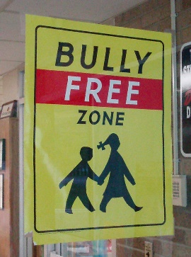

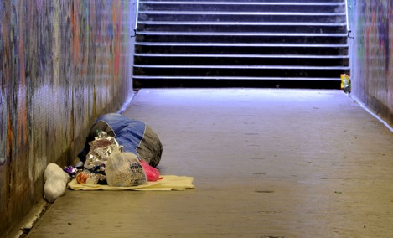

Image 1: Westfield Shopping Centre London by Martin and licensed for reuse under CC BY-ND 2.0 licence
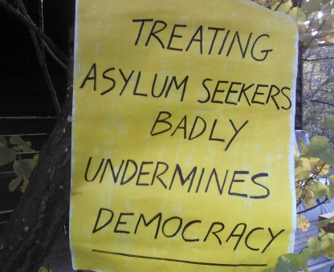

Image 4: Copyright Cheryl Howard and licensed for reuse under CC BY-ND 2.0 licence
Image 2: Copyright Albert Bridge and licensed for reuse under CC-BY-SA 2.0 licence



Image 5: Copyright Helga Weber and licensed for reuse under CC BY-ND 2.0 licence
Image 3: Copyright Eddie-S and licensed for reuse under CC-BY-ND 2.0 licence

Activity sheet: Which right?

Sam is a 19 year old and police have taken him for questioning in a relation to a crime. A neighbour took a photo of Sam which she posted on a council’s Facebook page.
The government wishes to build a new stadium in an area occupied by residential property (houses). All residents must sell their property or they will be evicted.
A major highway currently goes through the centre of a local town. The government has decided to build a new road by-passing this small town. This will mean fewer tourists will be passing through the town.
Aysha is 16 years old and she has commenced working as a receptionist in a real-estate agency on Saturday mornings. The agency is paying her $7 an hour.
In a school, newly arrived refugees were placed in a separate class. The school claims it is because of different learning needs and because they don’t speak English well.
A local shop has installed a device to stop young people loitering; it emits high-pitched frequencies to which young people are sensitive.
Local council has organised an event in a local hall for residents, but without access for people with a disability.

